11-8-14: Now that I had the mile stone 1 done I needed a RC car. So I got one from maplins, I got this one because it should fit in the pi, it is AA battery powered meaning that I know the current and voltage going to the car and it appeared to use analogue steering motors. After taking it apart, it did! So I can use it. Pictures taking it apart:

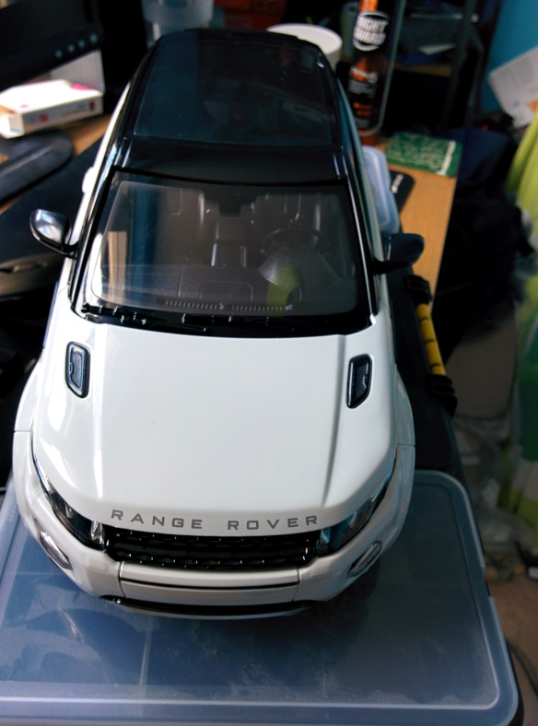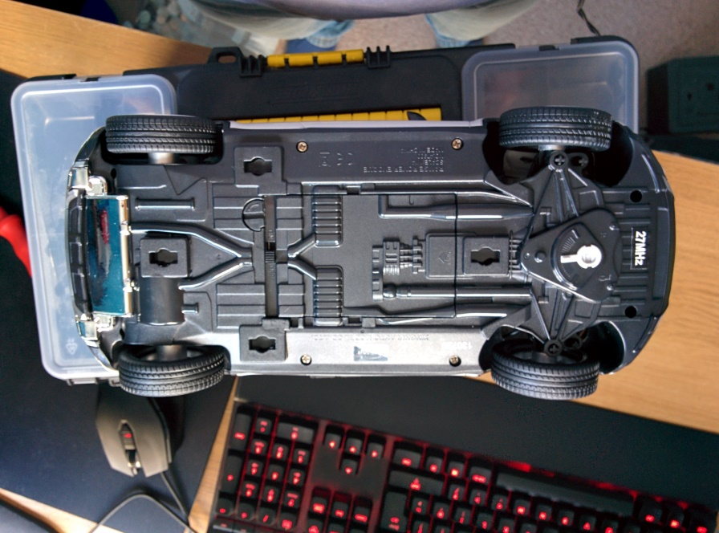



From this I can see it uses a relatively simple control board and it looks like it puts the full battery power thru the from and back motors, I need to check this first thow by using a volt meter.

This car also has lights so if I have time I could add a toggle for those. Eather in the app or as the car currently dose, have them on whenever the car is moving folward.

12-8-14: On inspection of the car this is a rough layout of the electronics (measured using a volt meater):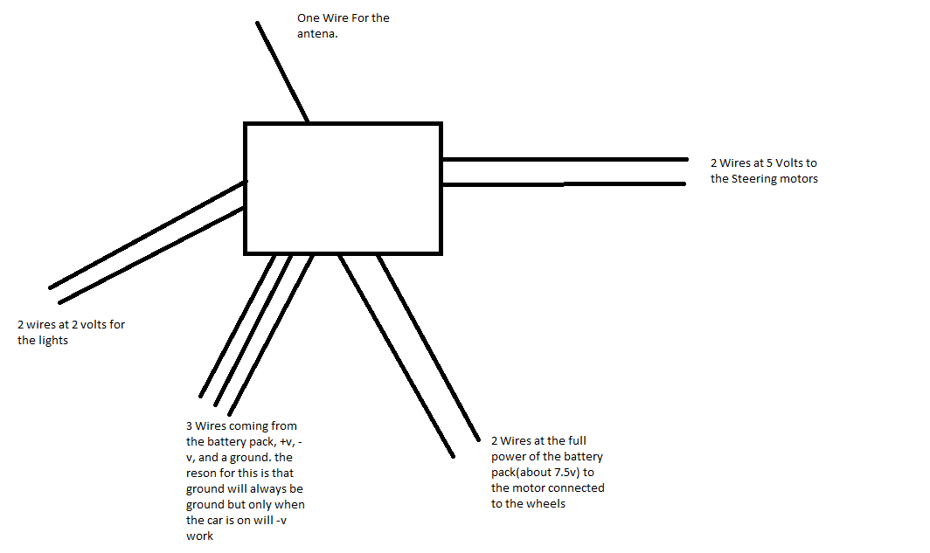

Things I have notesed while looking at the car: it has a ground as well as + and – volts, this is for the radio transmitter and receiver part of this I believe so I will not need this. Also both the motors appear to have a capacitor attached to them, this is what is refured to as a smoothing copasitor because it makes sure the current going in to the motor is steady, these I will keep attached to the motors.

Also there is a metal ring with wire wrapped around that appears to reduce the voltage to the motor(7.5 to 6.5 approximately) it will lightly do this so that the amps are higher meaning the motor will have more force. I will also keep this ring and lightly keep the wires running from the ring (cut them from the circuit board and cut of the insulation on the last 1cm of the wire, I will do this for the other motor and the lights(if they are used).

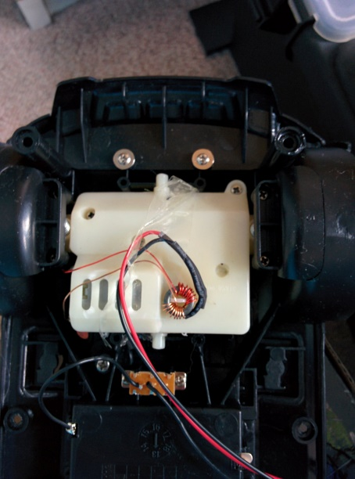

15-8-14: I have a few options on how I can wire/power the motors (each of these options is per motor), this is because a raspberry pi cant directly power a motor because the max output is 8mA.

1. I could use a transistor to power the motor, but this could get tricky as I would need another battery pack for the motor, I would then have 2 grounds: one on the battery pack and one on the PI, this could cause damage to the pi, but this should be fine if I do some research. The main problem would be that it would be hard to get the correct voltage to the motor because it would be the voltage of the gpio pin+ the voltage in(EG 3.3(from GPIO)v + 7.5v(for motor) so that means that 10.8v would go to the motor. This would lightly damage the motor.
2. I could use a relay but the GPIO pin on the PI is not powerful enough to power a relay so I would have to use a transistor to power the relay, this has the same problem of the different grounds.
3. After some research I found this: <http://computers.tutsplus.com/tutorials/controlling-dc-motors-using-python-with-a-raspberry-pi--cms-20051> So i could use the Motor driver and the schematics from this project, but I would need 2 of them because one motor is at 5V and one at 7.5V. also in a [datasheet for the L293](http://www.rapidonline.com/pdf/82-0192.pdf) I noticed that pin 8 must be higher than pin 16. Hopefully it will work if they are both 5V or I can covert 5 to 4.5 or power that with a 4.5v supply.

I will go with the Motor driver, because it will defiantly work. But I will have to order 2 and it may be a bit of a mess of wires.

I will also need a 7.5 to 5v converter so I have found one from [this project](http://www.instructables.com/id/Internet-Controlled-RC-Car/) (step 4).

I have ordered the components for the 5V regulator and the 2 motor drivers from rapid online. When they arrive I will build it using breadboard I already own and a set of male to female jumper wires and male to male jumper wires, also got from rapid online. The only thing I need now is 2 duel in line 16 pin chip holder that I will get locally because you can typically only buy them in bulk online. Once these come this will allow me to prototype it.

19-8-14: I first disconnected all the wires from the circit bord and labled them, then I assembled the cirict on bread board. I have just done the front and back motor(for the mean time).

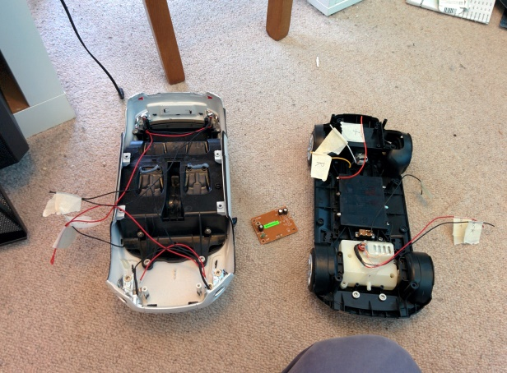



27-8-14: now that the hole program is working I will add the other motor in, I could do this by using the other output on the same L293D but because I need to convert it to 5V and this requires current to flow both ways this would not work, so instead I made a 5v converter circuit and used a second L293D.



4-9-14: now that I have the car’s electronics working completely I worked towards finishing it and putting it together. So to start I removed the seats from the RC car to make room for the electronics, I did this by removing 4 screws.

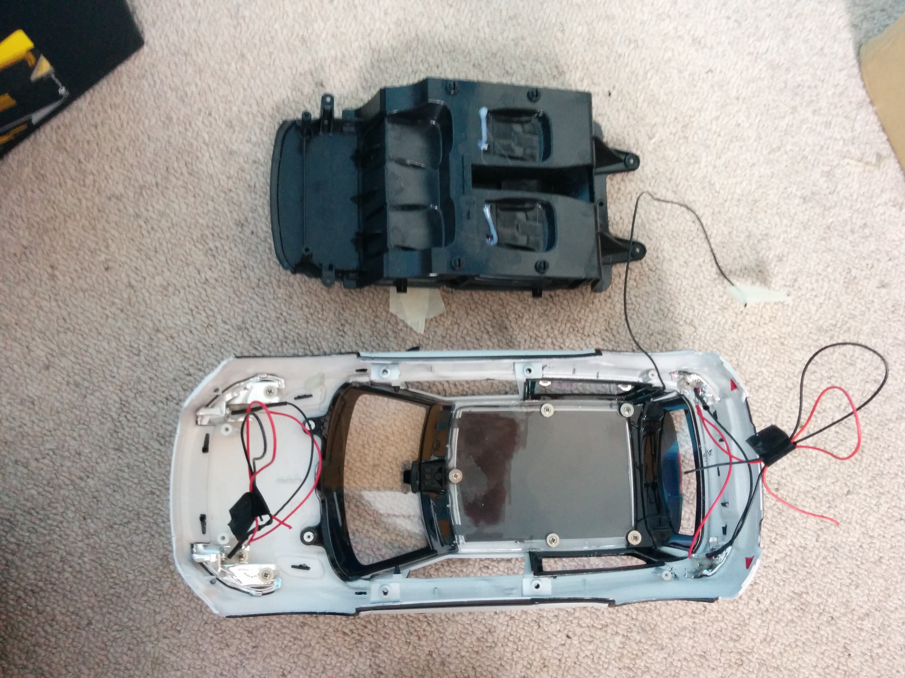

I then removed the roof (note dose not actually open the roof), this is a peace of plastic that secures the Arial in place and coves the front and side windows. I wanted to remove this so that I can access the things inside even when the lid is on and so that I can remove the Arial. I did this by remove the 7 skrews and then I had to squeeze it slightly go get it out.

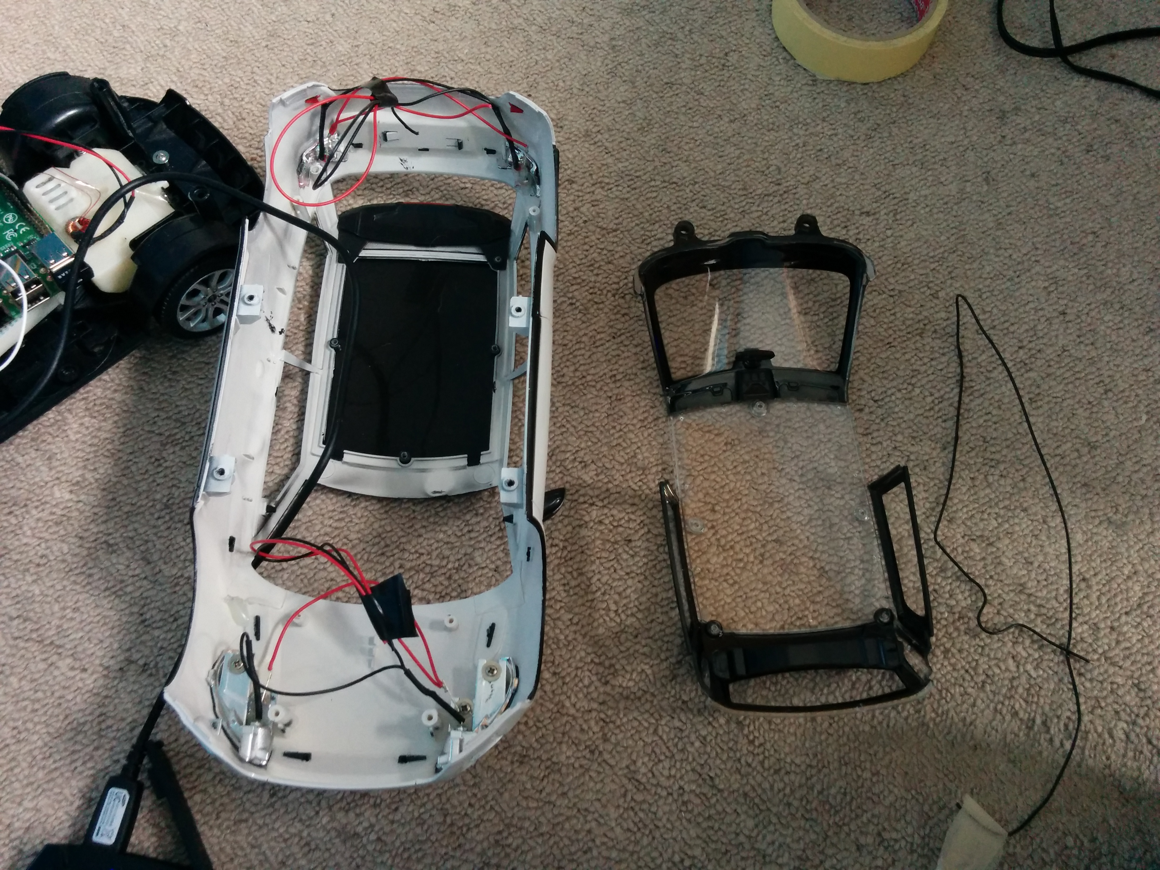

Finaly I have cut the wires for the lights very short and used electrical tape to hold then together this is because I don’t think I have the time to wire and code those, I have also put the battery pack thru front window so that it can be accessed easily. I also made it so that the left window could be used to access the IO(USB and Ethernet) .

This is at the point when the raspberry pi died see raspberry pi document. So I will finish theis when I get a new one.

4-9-14: I deside to re attach the new pi and the breadboard. So I secured the breadboard to the car using marsking tape along both sides and I secured the pi to the bread board using rols of marsking tape. I tried to use double stided stick tape but the pi dose not have a smoth bottom side so it did not work and the bread board dose not lye quite flush against the battery pack.



After I put the lid on I found a small usb cable (20cm) so I am going to be using this as it apperse to be a very good length. I initily tried attaching the battery pack to the roof, but the turning was very slow so I tried mounting it on the front and that worked slightly beater (still not brilliant) I think this is because the L293D is not desighned to work with 5v while being supplied with 5v and because the car is very heavy(hence moving the battery pack). I may need to fiddle with this more in the furture.